**Create a Windows virtual machine in the Azure portal**

Azure virtual machines (VMs) can be created through the Azure portal. This method provides a browser-based user interface to create VMs and their associated resources. This quickstart shows you how to use the Azure portal to deploy a virtual machine (VM) in Azure that runs Windows Server 2019. To see your VM in action, you then RDP to the VM and install the IIS web server.

If you don't have an Azure subscription, create a [free account](https://azure.microsoft.com/free/?WT.mc_id=A261C142F) before you begin.

**Sign in to Azure**

Sign in to the Azure portal at [https://portal.azure.com](https://portal.azure.com/).

**Create virtual machine**

1. Enter *virtual machines* in the search.
2. Under **Services**, select **Virtual machines**.
3. In the **Virtual machines** page, select **Create** and then **Azure virtual machine**. The **Create a virtual machine** page opens.
4. Under **Instance details**, enter *myVM* for the **Virtual machine name** and choose *Windows Server 2019 Datacenter - Gen 2* for the **Image**. Leave the other defaults.

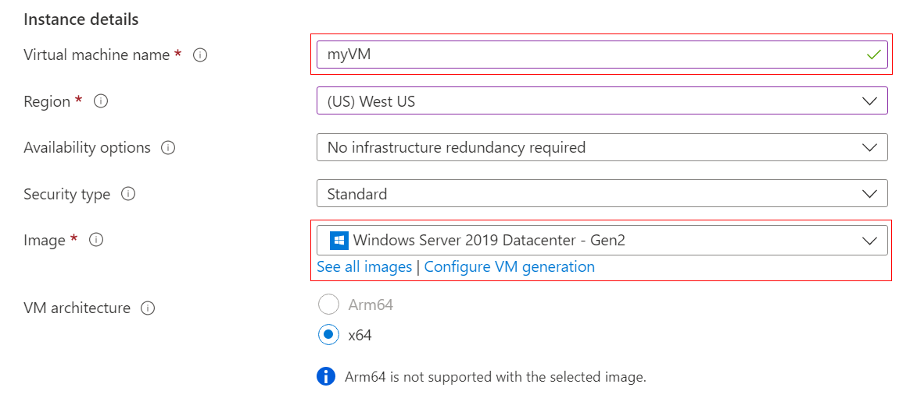

**Note**

Some users will now see the option to create VMs in multiple zones. To learn more about this new capability, see [**Create virtual machines in an availability zone**](https://learn.microsoft.com/en-us/azure/virtual-machines/create-portal-availability-zone). 

1. Under **Administrator account**, provide a username, such as *azureuser* and a password. The password must be at least 12 characters long and meet the [defined complexity requirements](https://learn.microsoft.com/en-us/azure/virtual-machines/windows/faq#what-are-the-password-requirements-when-creating-a-vm-).

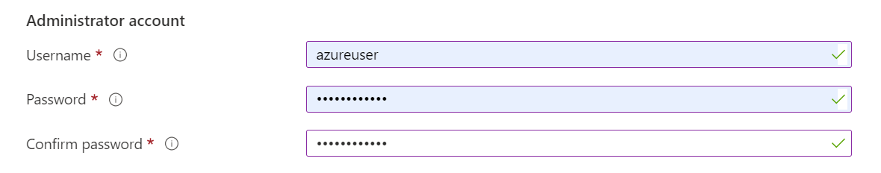

1. Under **Inbound port rules**, choose **Allow selected ports** and then select **RDP (3389)** and **HTTP (80)** from the drop-down.

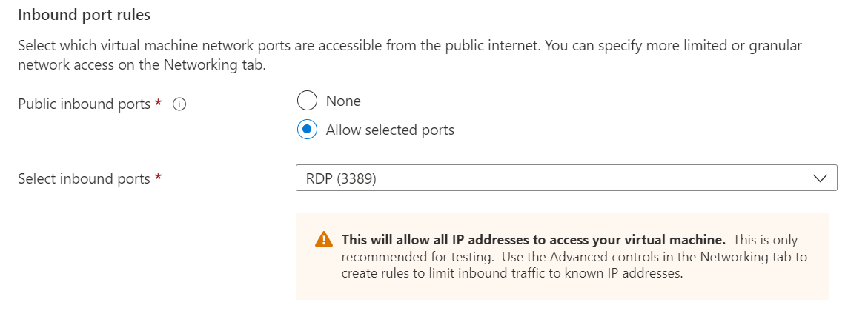

1. Leave the remaining defaults and then select the **Review + create** button at the bottom of the page.
2. After validation runs, select the **Create** button at the bottom of the page. 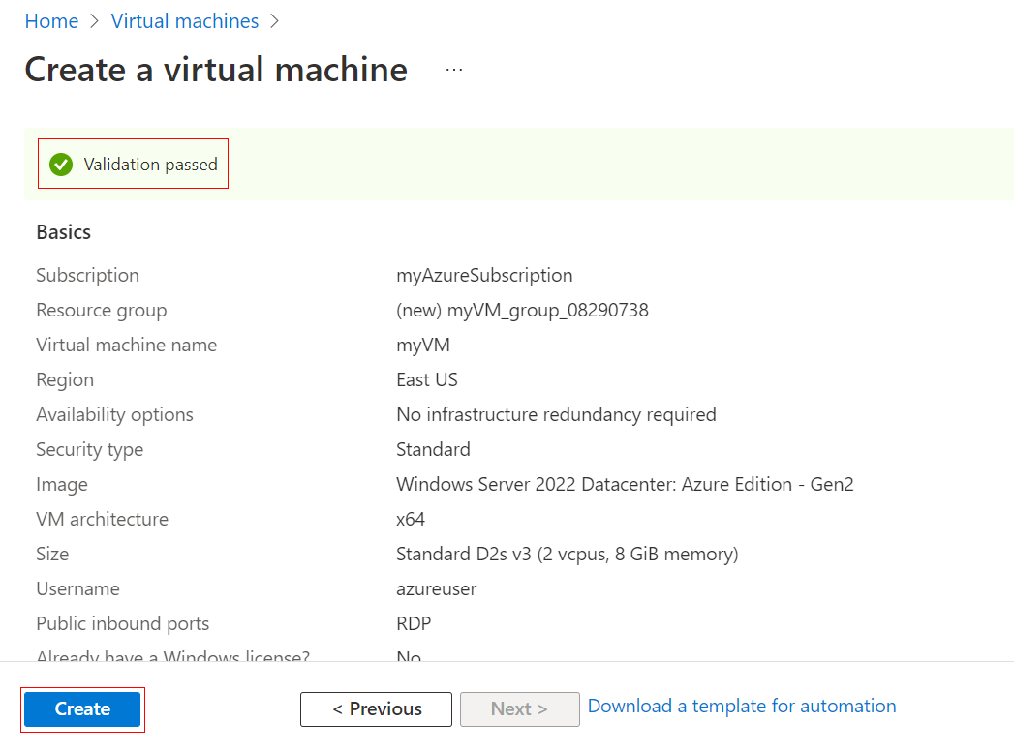
3. After deployment is complete, select **Go to resource**.

**Connect to virtual machine**

Create a remote desktop connection to the virtual machine. These directions tell you how to connect to your VM from a Windows computer. On a Mac, you need an RDP client such as this [Remote Desktop Client](https://apps.apple.com/app/microsoft-remote-desktop/id1295203466?mt=12) from the Mac App Store.

1. On the overview page for your virtual machine, select the **Connect** > **RDP**.
2. In the **Connect with RDP** tab, keep the default options to connect by IP address, over port 3389, and click **Download RDP file**.
3. Open the downloaded RDP file and click **Connect** when prompted.
4. In the **Windows Security** window, select **More choices** and then **Use a different account**. Type the username as **localhost**\*username*, enter the password you created for the virtual machine, and then click **OK**.
5. You may receive a certificate warning during the sign-in process. Click **Yes** or **Continue** to create the connection.

**Install web server**

To see your VM in action, install the IIS web server. Open a PowerShell prompt on the VM and run the following command:

PowerShellCopy

Install-WindowsFeature -name Web-Server -IncludeManagementTools

When done, close the RDP connection to the VM.

**View the IIS welcome page**

In the portal, select the VM and in the overview of the VM, hover over the IP address to show **Copy to clipboard**. Copy the IP address and paste it into a browser tab. The default IIS welcome page will open, and should look like this:

**Clean up resources**

When no longer needed, you can delete the resource group, virtual machine, and all related resources.

1. On the Overview page for the VM, select the **Resource group** link.
2. At the top of the page for the resource group, select **Delete resource group**.
3. A page will open warning you that you are about to delete resources. Type the name of the resource group and select **Delete** to finish deleting the resources and the resource group.